“SMART BUTTON” ( Meter level buttons “)

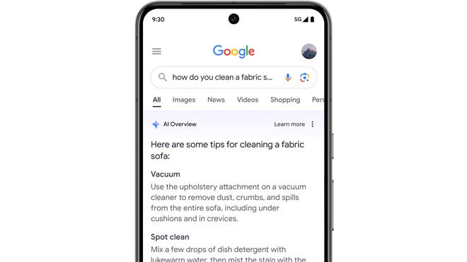

< Not Helpful Helpful>

